Finding a Website

 | 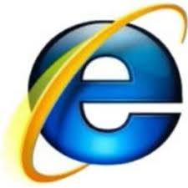 | 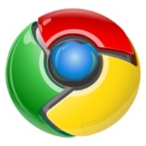
Mozilla Firefox | MS Internet Explorer | Google Chrome

Finding a website starts with a web browser – the three symbols above are three of the most popular browsers. To open one, find the symbol on the computer and click on it. The window that opens looks a little different for each browser, but they all have a similar layout (below)

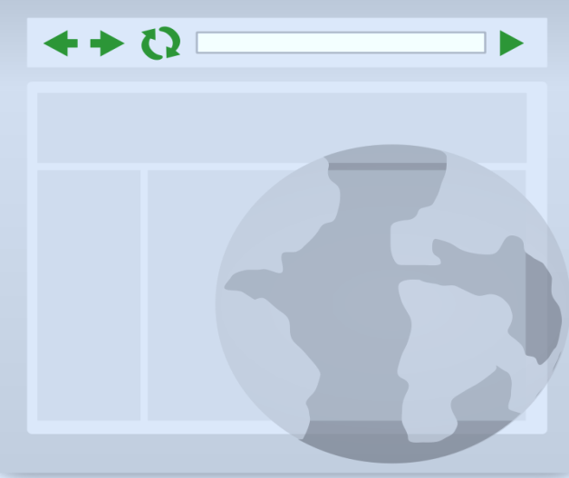
The box at top is called an address bar. If you know the address of the website you want to reach, enter it here:

http://e4vt.org/intro-to-the-web

Check the website spelling, press enter, and the browser will take you directly to the website.

If you don’t know the specific address of the site you want, look for smaller box to the right of the address bar or below it. It will be labeled with “search” or a magnifying glass. Enter a word or phrase that describes the site you are looking for and hit enter.
The browser will show a list of possible websites.

Click on the link (a blue underlined title ) that matches the site you want.

You will go directly to that site.

